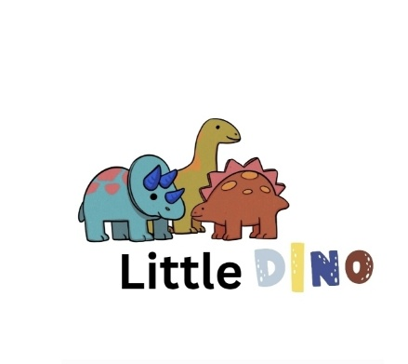

Aims:

* To promote positive attitudes towards oral health and hygiene.
* To encourage healthy eating and drinking habits that protect children’s teeth.
* To help children understand the importance of caring for their teeth through play and learning.
* To work in partnership with parents, carers, and health professionals to support children’s oral health.
* To comply with EYFS (2024) requirements for promoting good health and well-being.

Implementation:

1. Promoting Good Oral Health

* Staff talk to children about teeth and oral care using age-appropriate stories, songs, games, and visual aids.
* Activities are included in planning to promote healthy smiles (e.g. brushing role play with dolls, dentist role play area, sorting healthy/unhealthy food).
* Posters and displays remind children and families about tooth-friendly choices.
* Children are encouraged to drink water or milk only throughout the day. Sugary drinks are not permitted.

2. Food and Drink

* The playgroup follows a healthy eating policy that supports good dental health.
* Sugary snacks, sweets, and juice are not served at snack or mealtimes.
* Fresh fruit, vegetables, milk, and water are offered daily.
* Parents are encouraged to provide healthy lunchbox items (if applicable) and are given guidance on reducing sugar intake.

3. Tooth Brushing (if applicable)

- If the playgroup participates in a supervised tooth-brushing scheme:

* Children brush their teeth once per day after a meal or snack, under staff supervision.
* Each child has their own toothbrush and labelled storage** following NHS infection control guidelines.
* Toothpaste is fluoride toothpaste (1000 ppm or higher)and provided by the setting or NHS programme.
* Brushes are replaced termly or sooner if damaged.
* Staff are trained in safe brushing supervision and hygiene practices.
* If the setting does not currently operate tooth brushing, staff will still promote brushing at home and provide educational support for families.

4. Working with Parents and Carers

* Parents are encouraged to register their child with a dentist as soon as possible and attend regular check-ups.
* Information is shared with families about the importance of brushing twice daily and limiting sugary foods.
* Staff signpost parents to NHS resources, leaflets, and local oral health programmes.
* Where concerns about a child’s oral health arise (e.g. visible tooth decay or pain), staff will sensitively discuss this with parents and may suggest referral to a dentist or health visitor.

5. Training and Staff Awareness

* Staff receive basic training on oral health promotion and understand how diet, sugar, and routine affect teeth.
* Oral health messages are included in planning, circle time, and health education throughout the year.

6. Safeguarding and Inclusion

* All children are supported equally regardless of their background, culture, or previous dental experiences.
* Staff approach all discussions about oral health in a non-judgemental, supportive, and confidential** manner.
* Any safeguarding concerns arising from poor dental care (e.g. untreated decay causing pain or neglect) will be reported to the Designated Safeguarding Lead (DSL) in line with the Safeguarding Policy.

qHealth and Safety

* Staff maintain high hygiene standards when handling toothbrushes or oral health materials.
* All activities are risk assessed to ensure safety and prevent choking or contamination.

Legal Framework and Guidance

This policy is based on:

Statutory Framework for the Early Years Foundation Stage (EYFS, 2024)**l
NHS England – Children’s Oral Health Guidance**
Public Health England – “Delivering Better Oral Health” (2021)**
Health and Safety at Work Act (1974)**
The Eat Better, Start Better Guidelines

Review:

This policy will be reviewed annually or sooner if guidance or NHS recommendations change.

Reviewed by: Manager / Health and Well-being Lead
**Next Review Date: September 2026

