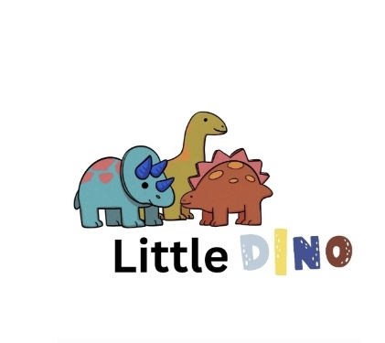
Safer Recruitment Policy for Little Dino Playgroup

Introduction

Little Dino Playgroup is committed to providing a safe and secure environment for all children, staff, and volunteers. Our Safer Recruitment Policy outlines the procedures and standards we follow to ensure that all staff and those working with children are suitable and qualified, thereby safeguarding children’s wellbeing.

Objectives

- To prevent unsuitable individuals from working with children.
- To promote a culture of safeguarding and vigilance.
- To ensure all recruitment processes are fair, transparent, and consistent.

Recruitment Procedures

1. Job Advertisements
- Clearly specify the role, responsibilities, and necessary qualifications.
- Emphasise our commitment to safeguarding and the importance of vetting.

2. Application Process
- Require completed application forms, including employment history and references.
- Discourage CVs alone; use application forms to gather consistent information.

3. Shortlisting
- Use a set of criteria aligned with the role’s responsibilities.
- Include safeguarding considerations in the shortlisting process.

4. Interviews
- Conduct structured interviews with questions focused on safeguarding, experience, and suitability.
- Include at least one question or scenario related to safeguarding.

5. Pre-Employment Checks
- Disclosure and Barring Service (DBS) Check: Obtain an enhanced DBS check before appointment.
- References: Contact at least two referees, including previous employers, to verify suitability.
- Identity Verification: Confirm identity using official documents.
- Qualifications: Verify relevant qualifications and training.
- Right to Work: Check legal eligibility to work in the UK.

6. Conditional Offer of Employment
- Made subject to satisfactory checks and references.
- Include a probationary period during which ongoing safeguarding assessments are carried out.

7. Induction and Training
- Provide safeguarding training to all new staff.
- Ensure staff are familiar with policies and procedures relating to child protection.

8. Record Keeping
- Maintain confidential personnel files, including vetting checks, interview notes, and training records.
- Keep records in accordance with data protection laws.

Ongoing Safeguarding

- Regularly review staff suitability and conduct safeguarding refresher training.
- Encourage a culture of openness where concerns can be raised safely.
- Ensure whistleblowing procedures are accessible and understood.

Agency Staff
APOGO AGENCY RECRUITMENT FOR EARLY YEARS QUALIFED PRACTITIONER

Review

This policy will be reviewed annually or following any safeguarding incident to ensure it remains effective and compliant with current legislation.

Signed:________Rouma Begum______________
Position: Manager/Designated Safeguarding Lead
Date:______24/10/25________________

Little Dino Playgroup is dedicated to ensuring a safe, nurturing environment for every child. Our recruitment procedures reflect this commitment.

