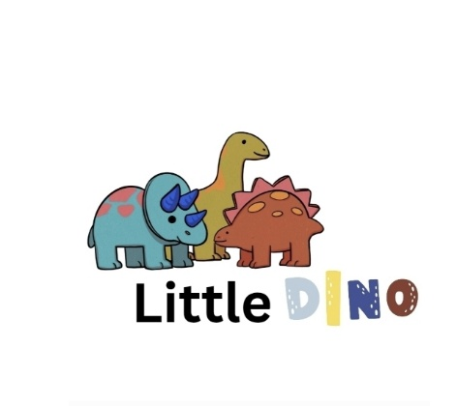

Little Dino Playgroup

Sitting Together Policy

Purpose:
At Little Dino Playgroup, we value opportunities for children to sit together during group times, snack times, and mealtimes. Sitting together helps children develop social skills, communication, and respect for others in a safe and nurturing environment.
Aims:

* To encourage children to sit together calmly and safely.
* To promote good listening, turn-taking, and sharing.
* To ensure all children feel included, respected, and valued.
* To support children’s social, emotional, and communication development.
* To maintain a safe, supervised environment during all sitting and eating times.

Implementation:

- Environment Setup:

* A safe, comfortable, and clearly defined sitting area will be arranged (e.g., carpet area, circle time mat, or tables).
* Staff ensure that seating and furniture are appropriate for the age and developmental stage of all children.

- Group Time Expectations:

* Children are encouraged to sit together in a circle or small group.
* Staff model appropriate behaviour, such as sitting nicely and listening attentively.
* Visual or verbal cues may be used to help children understand and follow expectations.

- Inclusivity and Support:

* All children are encouraged to participate, with sensitivity to individual needs, including SEND.
* Adjustments such as shorter sitting times, sensory breaks, or alternative seating may be provided.
* Staff work in partnership with parents and carers to understand each child’s needs and comfort levels.

- Snack and Mealtime Sitting:

* Children are encouraged to sit together at tables for snacks and meals.
* A member of staff will always remain seated with the children throughout snack and mealtime to ensure supervision, safety, and positive social interaction.**
* Staff model appropriate eating behaviour, conversation, and table manners.
* This time is used to encourage healthy eating habits and support children in developing independence (e.g., pouring drinks, using cutlery).

- Positive Reinforcement:

* Staff use praise and encouragement to reinforce positive behaviour.
* Gentle reminders and support are provided where needed.
* Simple reward systems (e.g., stickers, verbal praise) may be used appropriately.

Health and Safety:

* Staff always supervise sitting and eating areas to prevent accidents and choking risks.
* Children are reminded not to rock chairs or move around unsafely.
* All eating areas are checked for cleanliness and hygiene before and after use.
* Food safety and allergy procedures are followed in line with the setting’s Health and Safety Policy.

Review:

This policy will be reviewed annually or sooner if there are changes in guidance or best practice.

**Reviewed by:Manager / EYFS Lead
**Next Review Date: September 2026

