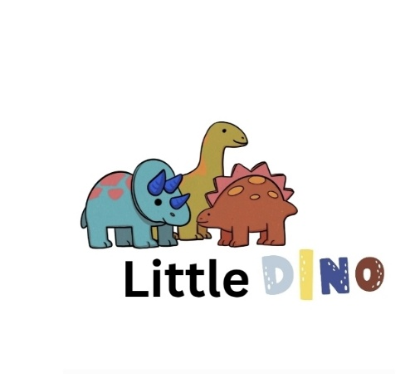

Little Dino Playgroup

Early Years Milestone Development – Staff Assessment Process

Purpose:
At Little Dino Playgroup, we are committed to tracking each child’s developmental progress through regular, accurate, and meaningful assessments. Our aim is to ensure every child receives the right support at the right time, helping them to reach their full potential across all areas of learning and development.

Aims:

* To monitor and record children’s progress against Early Years Foundation Stage (EYFS) milestones.
* To identify individual strengths and areas for further development.
* To plan appropriate next steps to support each child’s learning journey.
* To ensure assessments are consistent, inclusive, and reflective of each child’s unique abilities.
* To engage parents and carers as active partners in the assessment process.

Implementation:

1. Observation

* Staff observe children regularly during play and daily routines to gain a holistic view of their learning and development.
* Observations focus on the seven areas of learning and development within the EYFS:

* Communication and Language
* Physical Development
* Personal, Social and Emotional Development
* Literacy
* Mathematics
* Understanding the World
* Expressive Arts and Design
* Staff use a mixture of spontaneous (in-the-moment) and **planned observations.
* Observations include notes, photos, and examples of children’s work, reflecting their voice and interests.

2. Recording Progress

* Key Persons record observations using individual learning journals (digital or paper-based).
* Milestones are mapped using EYFS **development matters guidance (0–3 years, 3–4 years, and Reception age bands).
* Staff record each child’s progress termly to track development over time.
* Learning journals are shared with parents during review meetings and can be accessed upon request.

3. Assessment and Review

* Each child’s Key Person completes termly assessments, summarising progress and identifying next steps.
* Assessments are discussed with the Room Leader and Manager to ensure accuracy and consistency across the team.
* Children’s progress is rated as:

* Emerging – working towards expected milestones
* Developing– progressing well through milestones
* Secure– confidently meeting expected milestones
* Any concerns about progress or possible developmental delays are discussed confidentially with the SENCo (Special Educational Needs Coordinator).

4. Planning Next Steps

* Individual next steps are set following each assessment.
* Staff plan targeted activities and experiences based on each child’s interests, strengths, and areas for support.
* Next steps are shared with parents and reviewed regularly to ensure progress is ongoing and achievable.

5. Partnership with Parents

* Parents are encouraged to share observations from home to create a complete picture of each child’s development.
* Regular parent meetings are held termly to discuss progress and next steps.
* Staff provide suggestions for home learning to support continuity of development between home and playgroup.

6. Staff Training and Consistency

* All staff receive training in observation, assessment, and planning as part of their induction and ongoing CPD.
* Regular moderation meetings are held to ensure assessments are consistent and in line with EYFS expectations.
* Staff work collaboratively to share best practice and maintain accurate developmental tracking.

7. Transition and Summative Assessment

* When a child moves rooms or transitions to school, a summative progress report is completed and shared with parents and the next setting.
* Reports include the child’s strengths, interests, and areas for continued development.

Inclusion and Equality

* Assessments reflect each child’s individual background, culture, and additional needs.
* Staff adapt assessment methods for children with SEND, EAL, or other needs, ensuring equal opportunities for progress.

Record Keeping and Confidentiality

* All assessment records are stored securely and treated as confidential.
* Data is shared only with parents, carers, and professionals directly involved in the child’s care and development, in line with GDPR policy.

Review:

This policy and process will be reviewed annually or sooner if EYFS guidance or internal procedures change.

Reviewed by: EYFS Lead / Manager
Next Review Date: September 2026

